Robert Minson

January 15, 2023

SYM-408

Prof. Dilts

Design a Relational Schema

Entity Relationship Diagram (ERD)

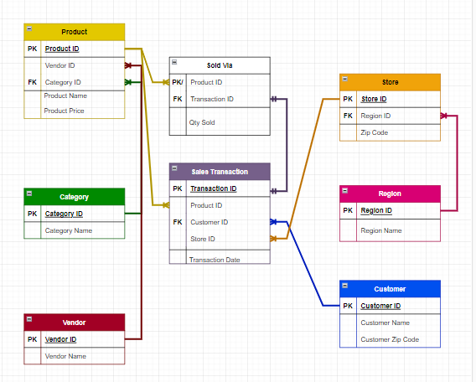

Product Table, Query to Bring Up Table, List of Tables

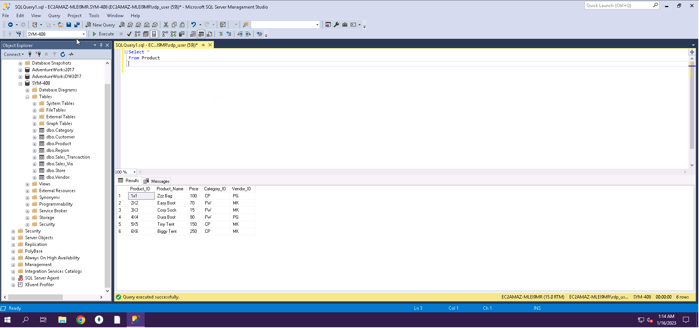

Category Table, Query to Bring Up Table, List of Tables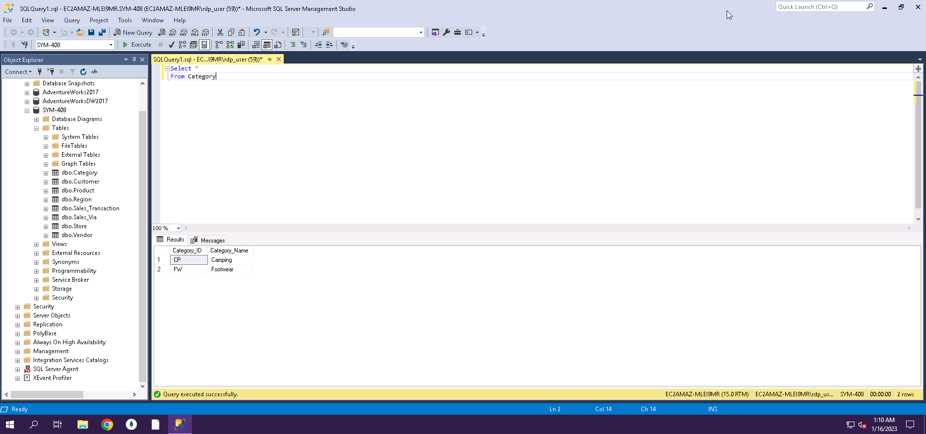

Vendor Table, Query to Bring Up Table, List of Tables

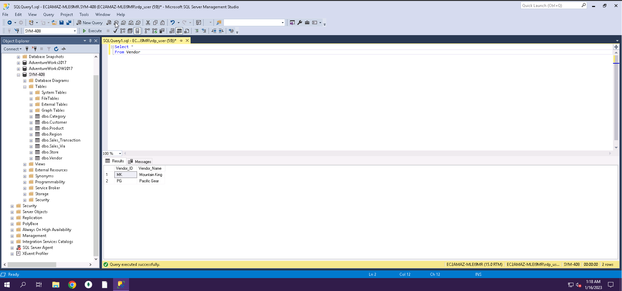

Customer Table, Query to Bring Up Table, List of Tables

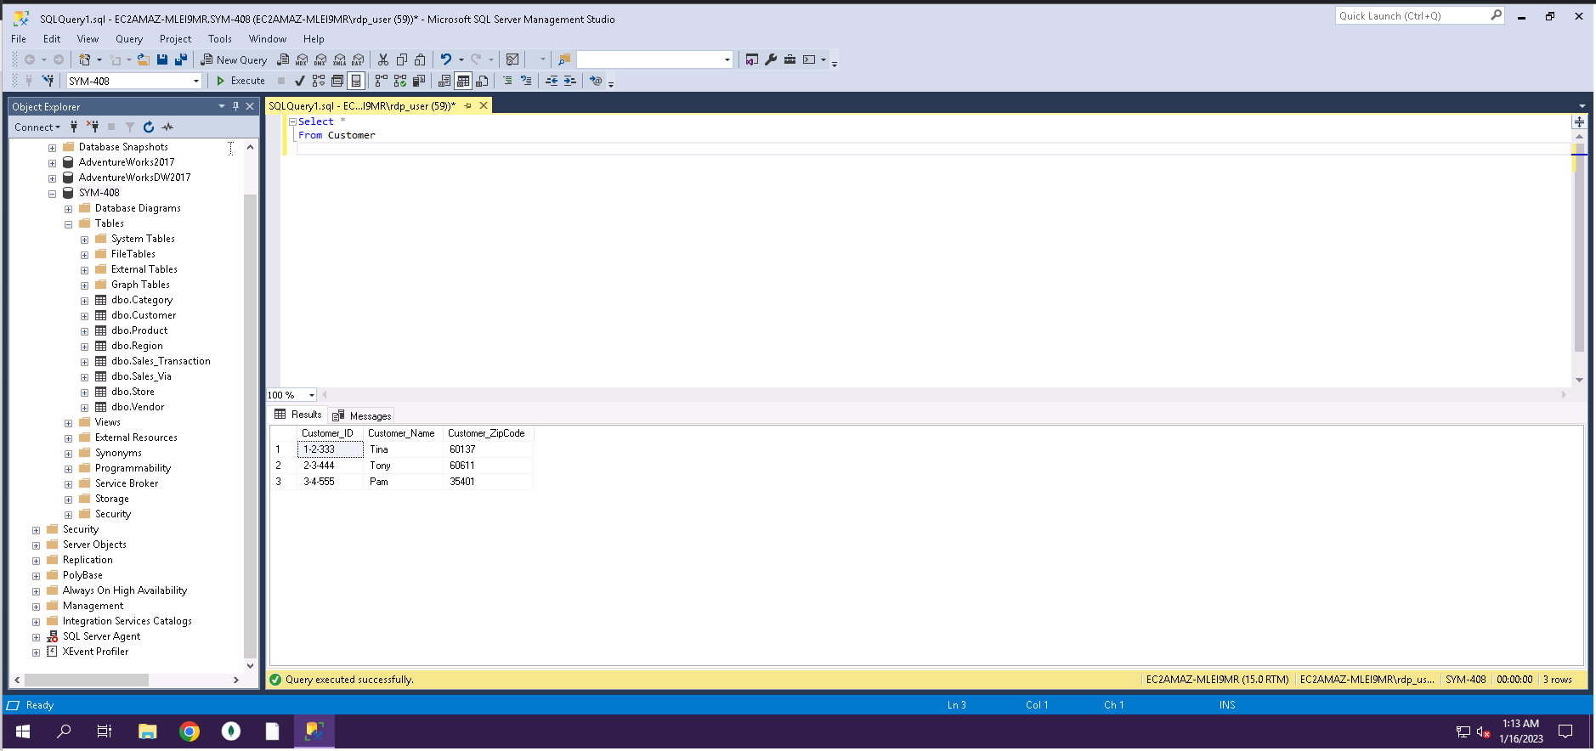

Store Table, Query to Bring Up Table, List of Tables

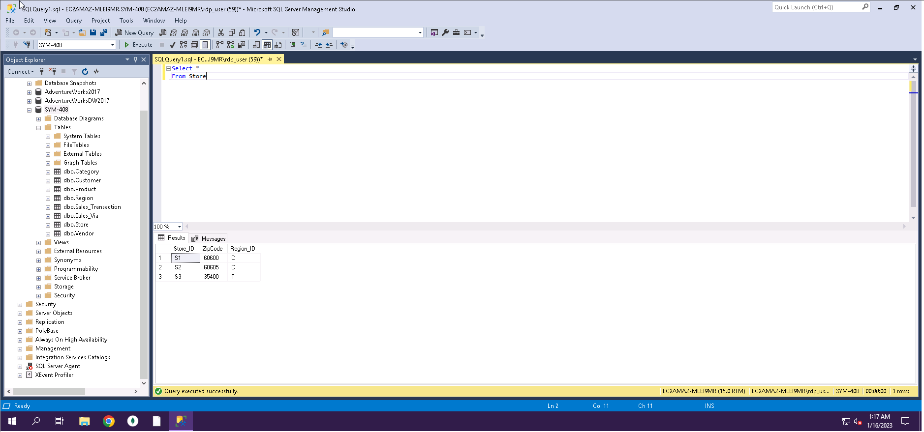Region Table, Query to Bring Up Table, List of Tables

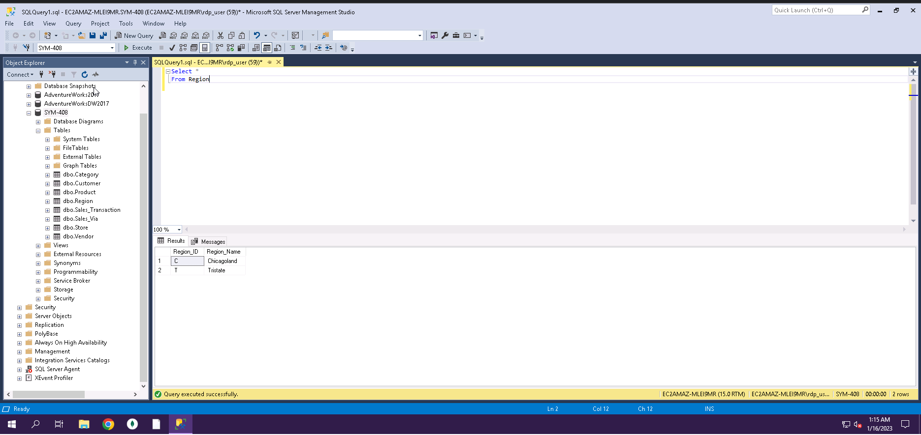

Sales Transaction Table, Query to Bring Up Table, List of Tables

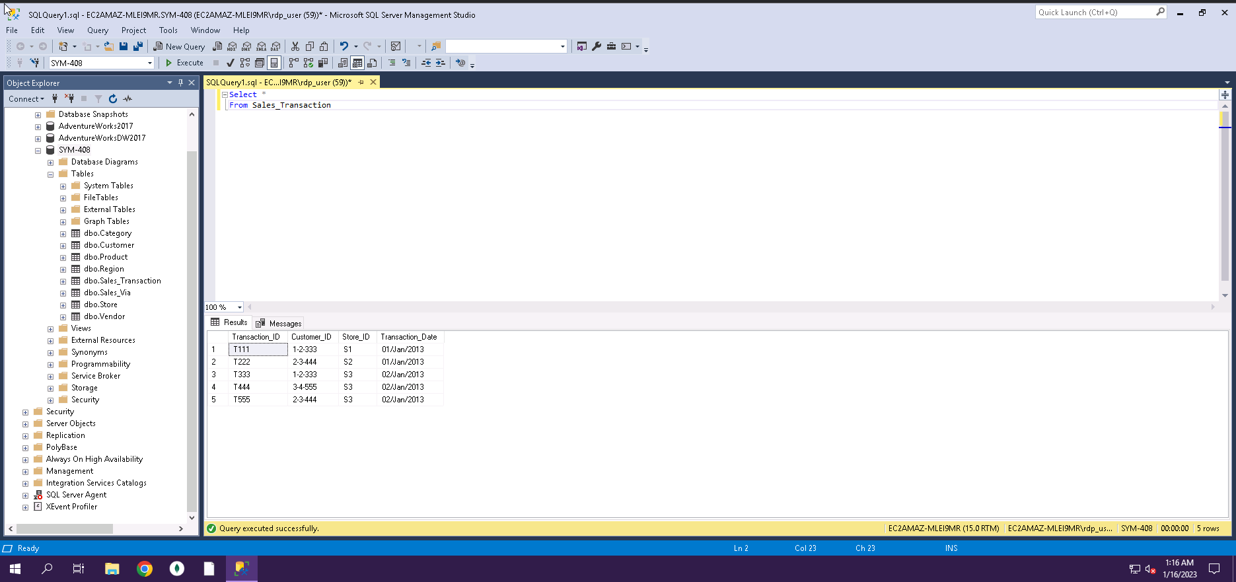

Sales Via Table, Query to Bring Up Table, List of Tables